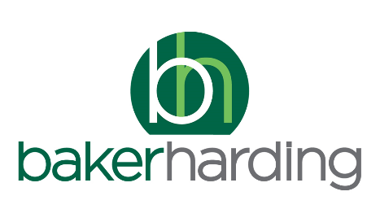**Modern Slavery Policy**

**October 2024**

1. Baker Harding is committed to eliminating modern slavery, human trafficking, forced labour, and similar human rights abuses.

2. Baker Harding is committed to ensuring that its staff and any workers it supplies (directly or indirectly) are not subject to behaviour or threats that may amount to modern slavery, human trafficking, forced labour, and similar human rights abuses.

3. Baker Harding provides appropriate training and awareness information for all staff.

In particular:

• All our staff receive awareness-raising information around issues involving modern slavery and human trafficking, so that they can bring any concerns they have to the attention of management.

4. Any staff, workers or other parties are strongly encouraged to report any concerns or suspicions that they might have to a Director of Baker Harding.

5. Reports surrounding these issues are taken extremely seriously by our board of, who are committed to ensuring that all investigations shall be prompt and effective. If our investigations reveal any issues, we are committed to taking appropriate action, including but not limited to:

• Working with the appropriate organisations to improve standards,

• Removing that organisation from our preferred supplier list,

• Passing details to appropriate law enforcement bodies.

6. We regularly monitor our risks in this area using relevant key performance indicators

This policy was review in October 2024 after being agreed by our board of. It will be reviewed again in April 2025.

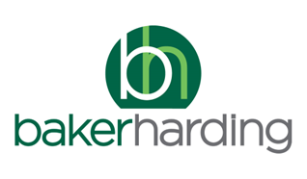

**Modern Slavery Statement**

This statement is made as part of Baker Harding’s commitment to eliminating the exploitation of people under the Modern Slavery Act 2015 (the Act). It summarises how Baker Harding operates, the policies and processes in place to minimise the possibility of any problems, any risks we have identified and how we monitor them, and how we train our staff.

This statement is published in accordance with section 54 of the Act and relates to the financial year April 2024 to March 2025. It was approved by the board of directors.

Jo Ferrett

Director

**1 Our Business**

Baker Harding is a limited company operating in the recruitment sector. We provide introduction services and supply temporary in the Industrial and Clerical sectors.

Baker Harding is an independent business.

**1.1 Who we work with**

All the hirers that we work with, and all the work-seekers we provide, are known to and identified by our staff. All the temporary workers we supply are identified by our staff.

The hiring companies that we work with are located across the UK. The work-seekers / workers we supply live in the UK.

**1.2 Other relationships**

The Recruitment and Employment Confederation (www.rec.uk.com) and the Institute of Recruitment Professionals (www.rec-irp.uk.com)

**2 Our Policies**

Baker Harding has a modern slavery policy available on request,

**2.1 Policy development and review**

Baker Harding’s policies are established by our directors, based on advice from HR professionals, industry best practice and legal advice, and in consultation with the REC. We review our policies on a regular basis, or as needed to adapt to changes.

**3 Our Processes for Managing Risk**

To assess the risk of modern slavery, we use the following processes with our suppliers:

* When engaging with suppliers, we ask for evidence of their processes and policies, including commitments around modern slavery, human trafficking, forced labour, human rights, and whistle-blowing.
* We review the potential for risk at regular intervals, including the possibility of re-auditing a supplier or conducting spot checks.

After due consideration, we have not identified any significant risks of modern slavery, forced labour, or human trafficking in our supply chain. However, we continue to be alert to the potential for problems.

Additionally, we have taken the following steps to minimise the possibility of any problems:

* We reserve the right to conduct spot-checks of the businesses who supply us, to investigate any complaints.
* We ensure that all our suppliers are members of appropriate industry bodies and working groups.

Our staff are encouraged to bring any concerns they have to the attention of management.

**4 Our Training**

All our staff receive training and support that is appropriate to their role. In particular:

All our staff receive awareness-raising information around issues involving modern slavery and human trafficking, so that they can bring any concerns they have to the attention of management.

As part of this, our staff are encouraged to discuss any concerns that they have.

Training is refreshed regularly.